0. Database Generation

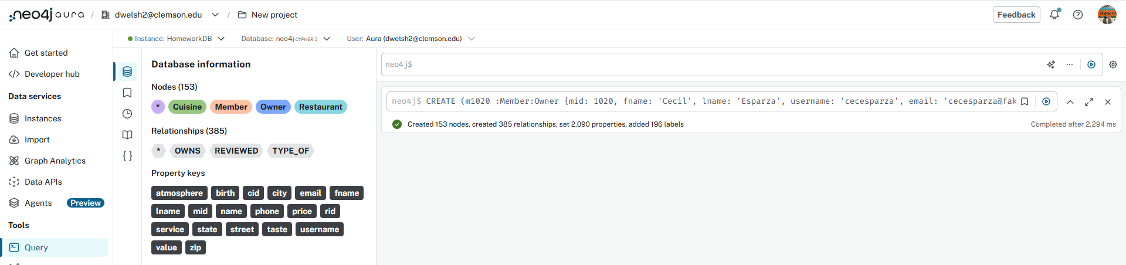

1. Adding Dabo Sweeny to the DB
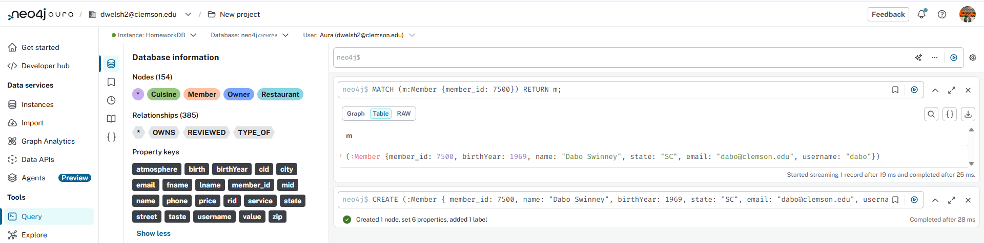

2. Setting the Tiger Chow Restaurant
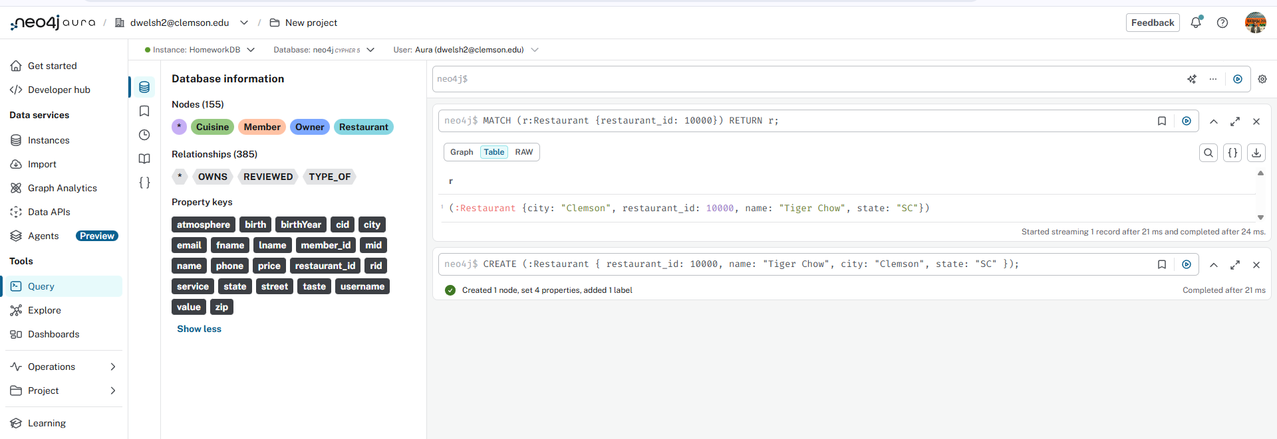

3. Updating Tiger Chow

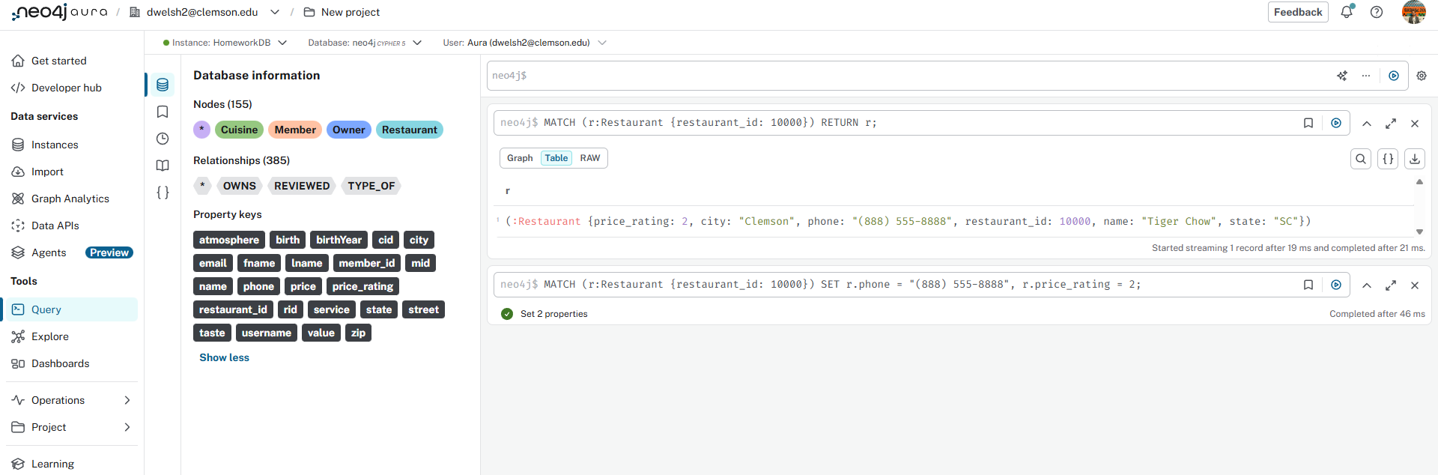

4. Creating the Reviewed Relationship

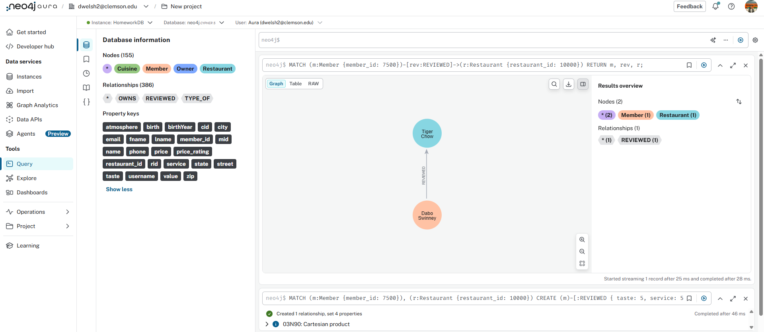

5. Created Fran’s reviewed relationship
I should’ve asked how you’d wanted these formatted, but I’m pushing both images I figured would be relevant

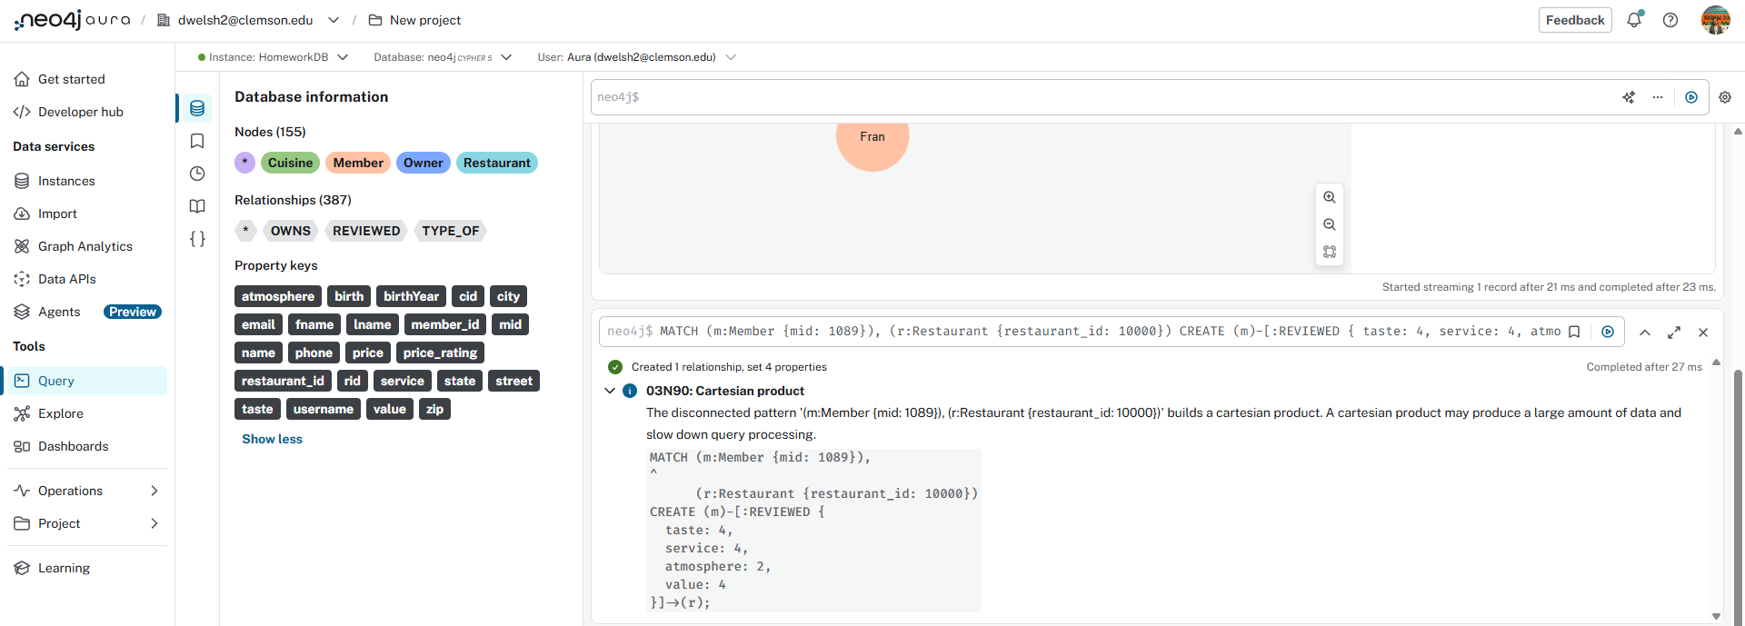

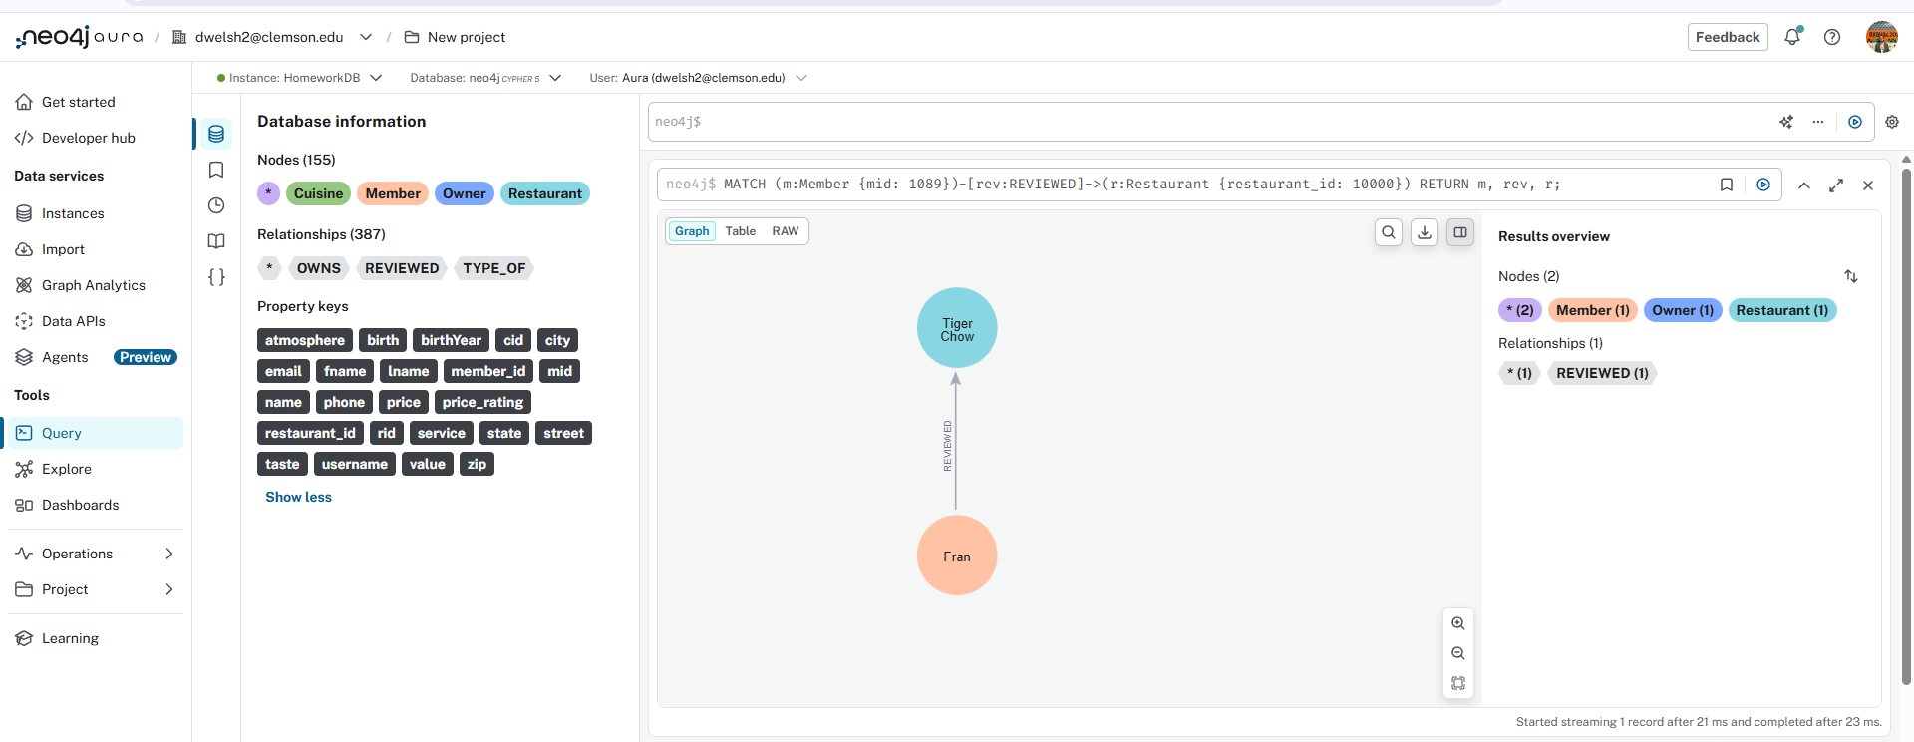

6. Queried the restaurants that Fran could stand
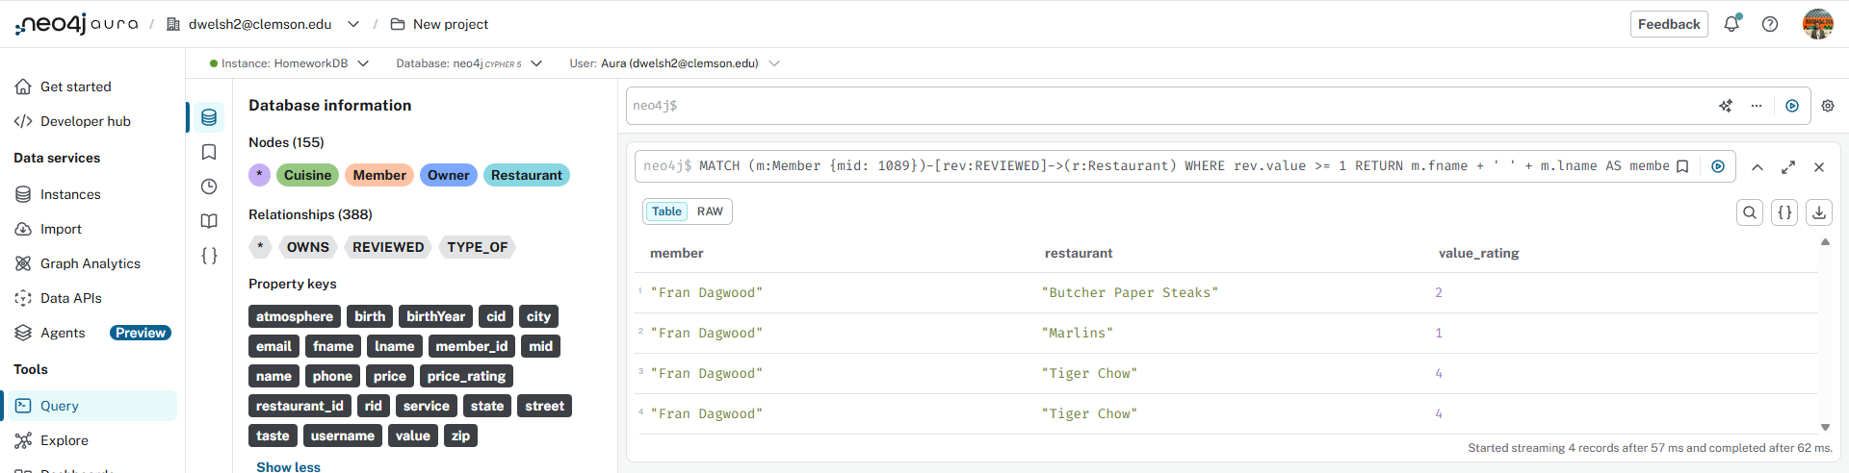

7. Queried the Italian and Seafood Restaurants
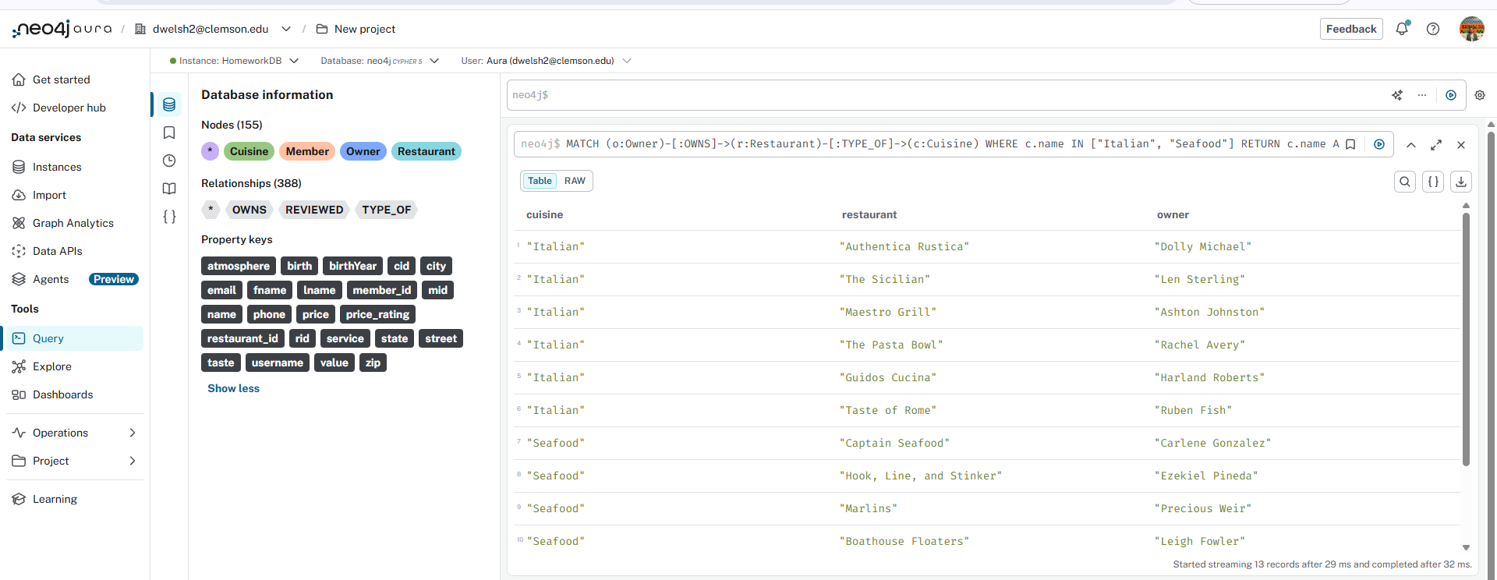
8. Find the shortest path between Dabo and Herb

